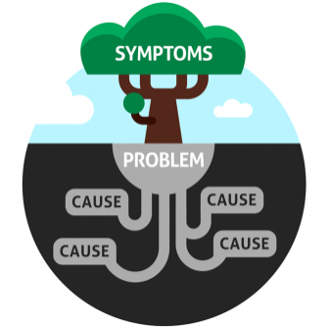
Dodge City Middle School LATE START – February 10, 2016
*Please remember to bring your iPad.

Everyone will meet in the band room.
Table Group Facilitators - PLC/Team Leaders (See TABLE GROUPS below.)
WHEN | WHO | WHAT & WHY
8:05–8:15 | Lisa Pelton | OVERVIEW – Better Teacher Communication: Restructuring Conferences  - Root Cause Priority: To what extent are resources/tools provided to inform PARENTS of what students are expected to know, do & demonstrate?  - How can we redefine our conference time in order to help parents better understand their students?  - How can we look at the conference activity as a “marathon, not a sprint,” as an opportunity to check in on students’ middle school journey that builds to their 8th grade spring conference where each student presents their journey & growth to their community?
8:15–8:35 | Table Groups & Facilitators | DRIVING QUESTION for Restructuring our Conferences  If you could restructure conferences to improve our communications & needs between teachers, parents & students, what would they look like? (to family, teachers, friends…)  ACTIVITY #1  - Brainstorm Driving Question – (Poster paper & markers)  - Then each table group will put their thoughts into a what they perceive to the “perfect” plan. How would teachers want conferences to be designed? (Poster paper & markers)
8:35–8:55 | Whole Group Shareout | Activity #2  - Each of the 9 groups presents their “conference plan” to the whole group & hangs poster. Listen for the common threads.  - Time: 3 minutes per group
8:55-9:15 | Table Groups & Facilitators | Activity #3  - Each of the 9 groups will rotate through the posters to find common threads based upon the Driving Question.  - Time: 3 minutes per poster
9:15-9:25 | Table Groups & Facilitators | Activity #5  Ticket Out –  - Each person identifies what they believe is an important outcome for developing a building wide plan.  - Table group members then go back & vote using their 5 sticky dots on what they believe should be the focus, the common thread, something that everyone can have buy-in.
9:25 Teachers return to classrooms.
9:35 1st period starts (Refer to Late Start Schedule for remainder of the day.)

